SYSTEM DESIGN

Data Flow Diagram / Use Case Diagram / Flow Diagram

The DFD is also called as bubble chart. It is a simple graphical formalism that can be used to represent a system in terms of the input data to the system, various processing carried out on these data, and the output data is generated by the system.

Data Flow Diagram
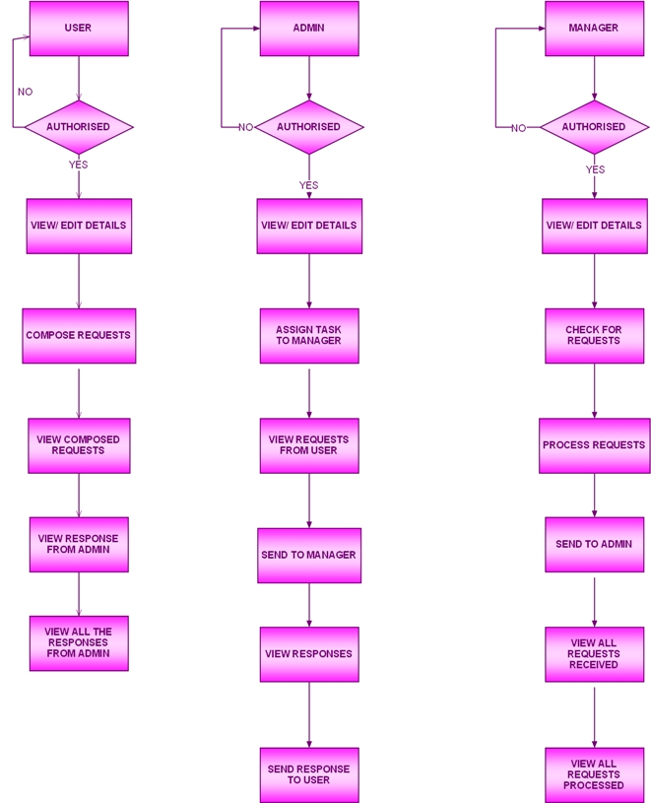
Use Case Diagram
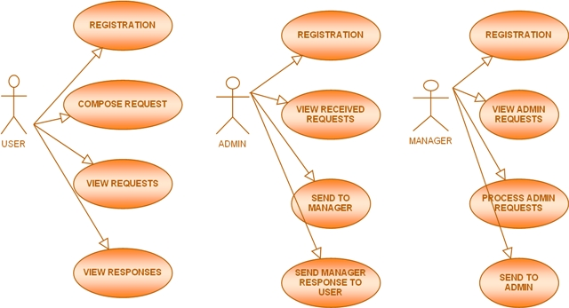
SEQUENCE DIAGRAM
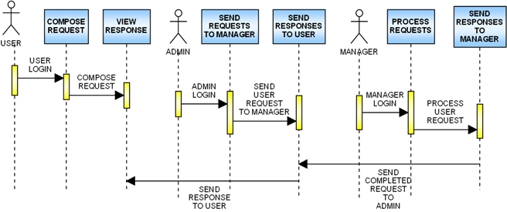

SYSTEM Flow Diagram

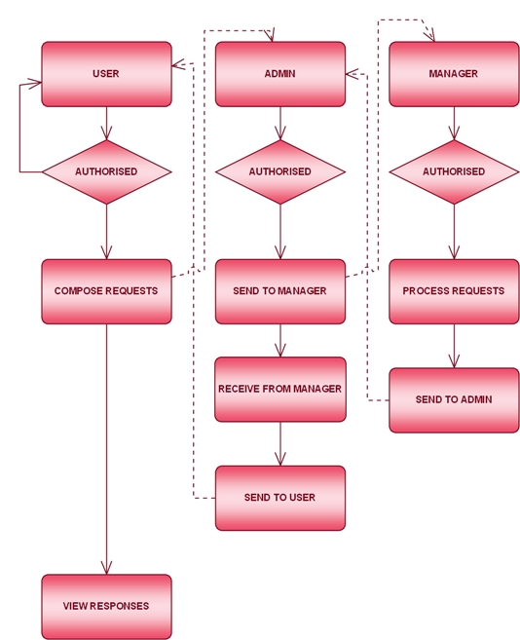

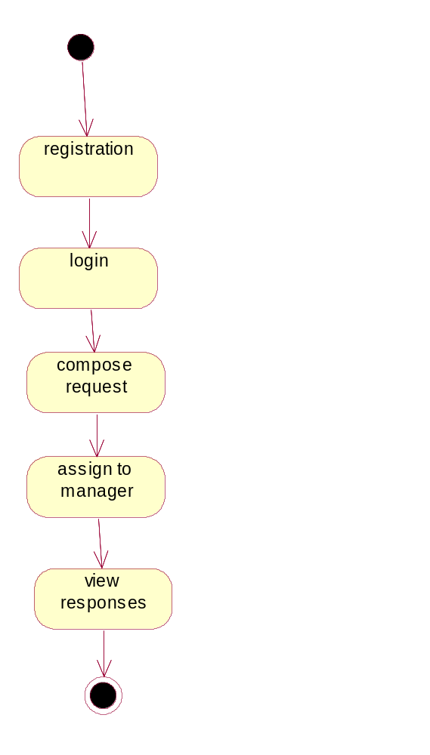

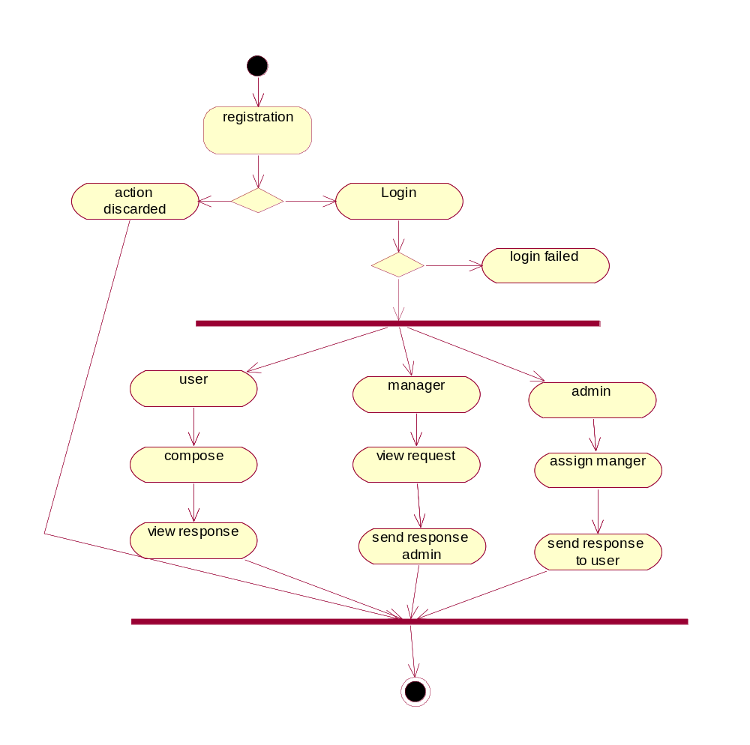

Class diagram
